**FOR IMMEDIATE RELEASE**

**LG AND MERCEDES-BENZ STADIUM FORM MULTI-YEAR PARTNERSHIP TO ELEVATE THE FAN EXPERIENCE**

*98-Screen Field Level Pitch LED Ribbon- Board Among Hundreds of LG DVLED and LCD Displays Being Installed Throughout World-Class Sports and Entertainment Venue*

**ATLANTA, April 16, 2025** — Joining forces to enhance and extend in-stadium fan experiences in exciting new ways, [LG Electronics USA](http://www.lg.com/us/business) and Mercedes-Benz Stadium have announced a multi-year partnership making LG a proud partner of the world-class sports and entertainment venue.

As part of this new relationship, LG is providing hundreds of new LG DVLED and LCD displays for installation throughout the venue, led by a robust 98-screen pitch LED ribbon-board, that provides a vivid, field level backdrop for all Atlanta United Home matches, LG’s first such implementation in the United States.

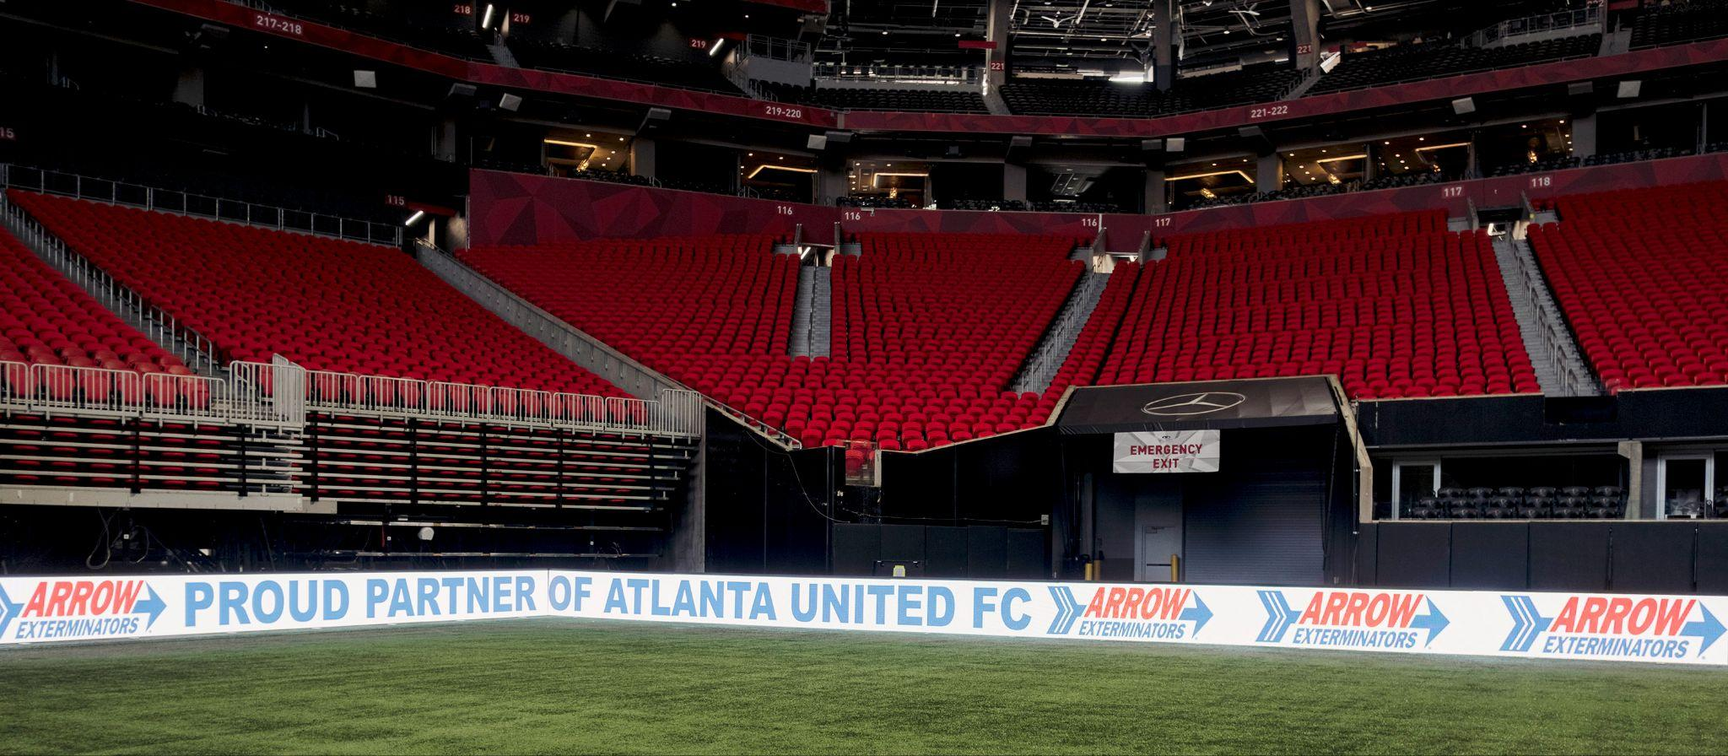

“We are proud to partner with the Mercedes-Benz Stadium team to install LG’s innovative display technology throughout this magnificent sports and entertainment venue, from the unique field pitch boards to bars and club experience zones,” said David Bacher, head of B2B marketing at LG Electronics USA. “Over the course of this partnership, we look forward to helping Mercedes-Benz Stadium achieve its goal of making the fan experience more compelling and engaging with our display solutions.”

Kevin Pope, vice president and chief information officer, AMB Sports and Entertainment, noted that, “Already offering world-class sport and live music entertainment, Mercedes-Benz Stadium is now looking to the future by adding the best display technology from the field level to bars and guest engagement zones.

“This expanded partnership builds on our positive history of working with LG and the confidence we have in the LG brand. We’ve had LG digital displays in the stadium since we opened and have long appreciated their reliable performance and value.”

As part of an ongoing stadium-wide display technology refresh ahead of the 2025 Club World Cup and 2026 FIFA World Cup, LG LED displays are now being installed across multiple areas of the venue, including the Gallagher Club and Lounge at Molly B’s, concourse areas, clubs and the most unique being the field level pitch boards used for soccer matches.

Tom Bingham, LG Electronics USA’s B2B vertical markets director, explained that the 98-screen field-level LED ribbon display features a unique technology over each display that helps protect the screens from impact and allows the uniquely portable advertising and information display solution to be stored away between matches played by Atlanta United and the Atlanta Falcons. The specially designed display can also be used for other events where field level signage is required.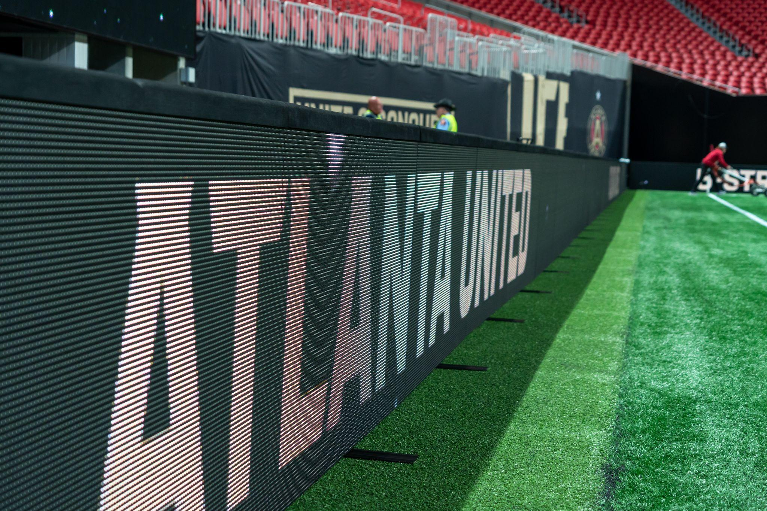

The stadium will debut the new field level display to soccer fans beginning February 22, Atlanta United’s opening match of the season. “These lightweight, durable displays offer easy setup and enhance the fan experience while creating new engagement opportunities for our partners,” concluded Pope.

LG’s Bingham added, “Creating unique display solutions that enable our customers like Mercedes-Benz Stadium to generate better fan experiences and enhanced revenue streams is at the core of what LG does best. We won’t consider the task finished until and unless our customers are completely satisfied with the solution we develop together, as a team.”

To learn more about LG’s LED and LCD display solutions, please click [here](https://www.lg.com/us/business/commercial-displays). For images, click [here](https://drive.google.com/drive/folders/1fRYIxjCGswWgSqW3K5vtgDLvmTYtEO7o?usp=drive_link). To learn more about the Mercedes-Benz Stadium, click [here](https://www.mercedesbenzstadium.com/).

# # #

**About LG Electronics USA**

LG Electronics USA serves commercial display customers in the U.S. lodging and hospitality, digital signage, systems integration, healthcare, education, government and industrial markets. Based in Lincolnshire, Ill., with its dedicated engineering and customer support team, LG’s U.S. Media Entertainment Solution B2B division delivers business-to-business technology solutions tailored to the particular needs of business environments. Eleven-time ENERGY STAR® Partner of the Year LG Electronics USA Inc., headquartered in Englewood Cliffs, N.J., is the North American subsidiary of LG Electronics Inc., a $60-billion-plus global force in consumer electronics, home appliances, eco solutions and vehicle components. For more information, please visit www.LGSolutions.com.

**About Mercedes-Benz Stadium**

Opened in 2017, Mercedes-Benz Stadium is a world-class sports and entertainment venue in downtown Atlanta and home to the National Football League’s Atlanta Falcons and Major League Soccer’s Atlanta United. The multi-purpose stadium was named the 2019 Sports Facility of the Year and is host to major sports and entertainment events, including eight matches for FIFA World Cup 26, 2025 FIFA Club World Cup, the 2018 and 2025 College Football Playoff National Championship Games, 2031 NCAA Men’s Final Four, 2018 MLS Cup, Super Bowl LIII, and the SEC Football Championship Game. Mercedes-Benz Stadium is the first professional sports stadium in North America to achieve LEED Platinum Certification and the first stadium worldwide to achieve TRUE Platinum Certification for zero waste by the United States Green Building Council. Mercedes-Benz Stadium is proud to be collaborating with naming rights partner Mercedes-Benz and thirteen founding partners including Coca-Cola, Equifax, The Home Depot, Novelis, SCANA Energy, Truist, IBM, Georgia Power, American Family Insurance, Global Payments, Ticketmaster, Delta Airlines, and Emory Healthcare.

*Media Contacts:*

LG Electronics USA

Kim Regillio

+1 815 355 0509

kim.regillio@lge.com

[www.LGsolutions.com](http://www.lgsolutions.com)

Caleigh McDaniel

caleigh@griffin360.com